🧪 PortSwigger Lab Write-Up

User role can be modified in user profile (APPRENTICE)

📌 Lab Information
- Lab Name: User role can be modified in user profile
- Difficulty: Apprentice
- Category: Access Control / Privilege Escalation
- Target Application: PortSwigger Web Security Academy

🎯 Objective
Gain unauthorized access to the /admin panel by escalating privileges and delete the user carlos.

🔐 Given Credentials
Username: wiener
Password: peter

🛠 Tools Used
- Web Browser (Chrome / Firefox)
- Burp Suite Community / Professional
- PortSwigger Web Security Academy Lab Environment

🧠 Vulnerability Overview
The application allows users to update their profile details (email). However, the backend does not properly validate sensitive parameters such as roleid.
This leads to Insecure Direct Object Reference (IDOR) / Access Control Misconfiguration, allowing privilege escalation by manipulating request data.

🧩 Step-by-Step Exploitation

1️⃣ Login to the Application
- Log in using the provided credentials (wiener:peter).
- Navigate to My Account page.
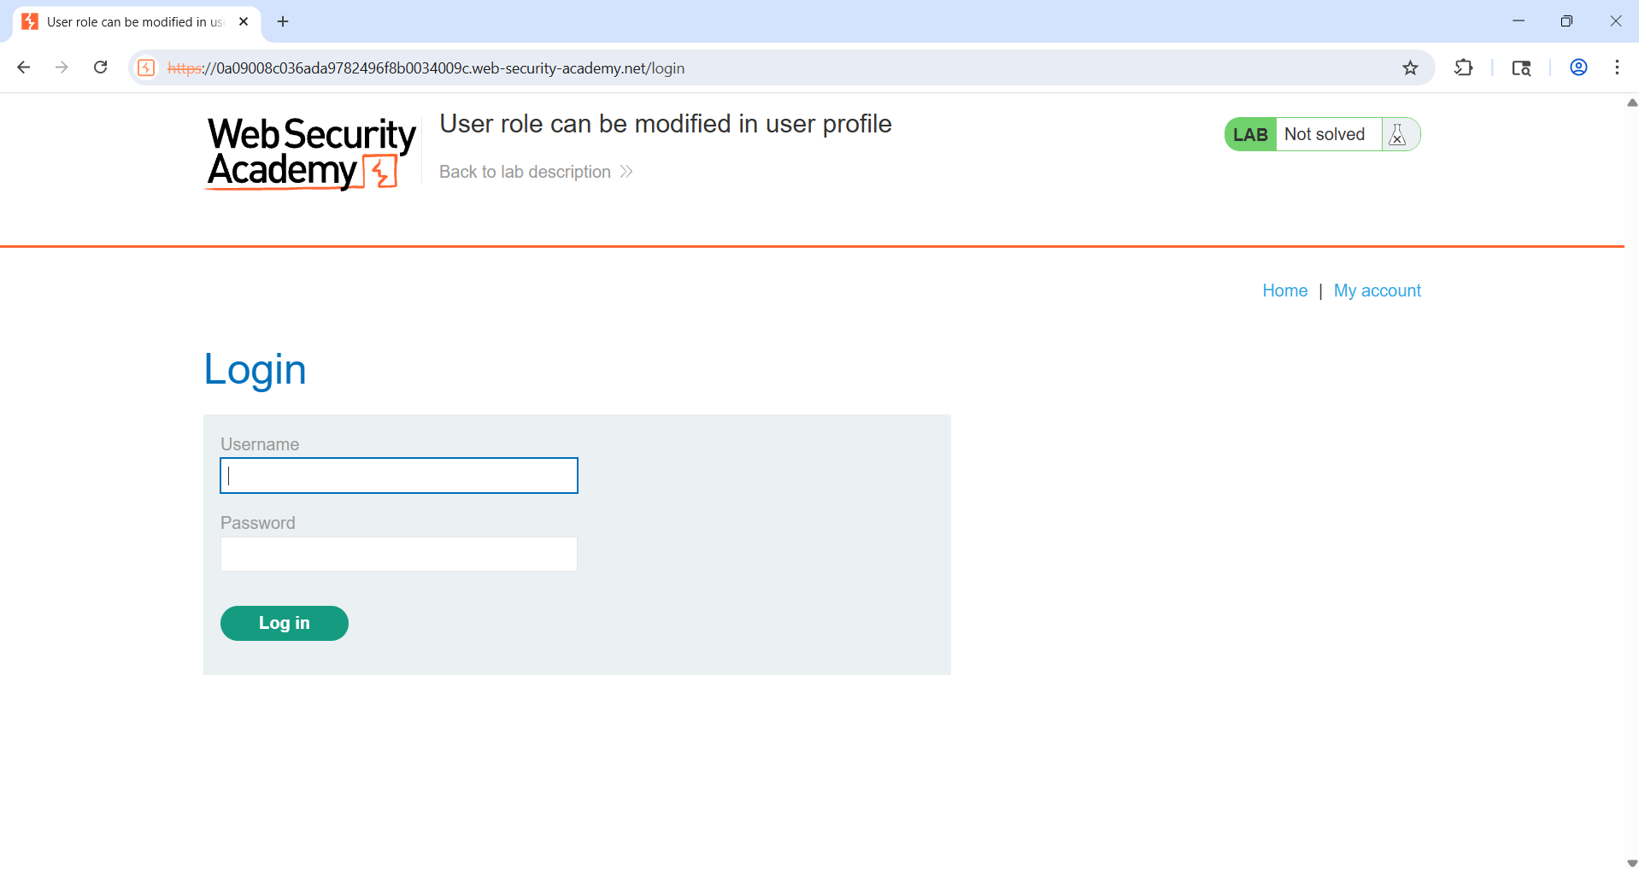

2️⃣ Update Email Address
- Use the email update feature in the profile page.
- Enter any valid email address and submit.
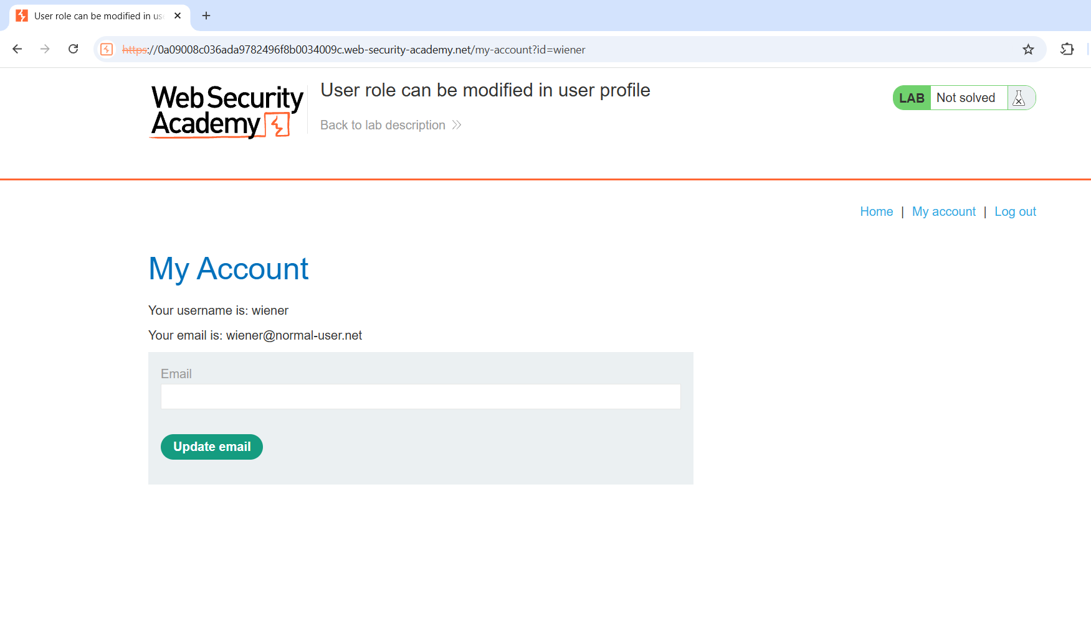

3️⃣ Intercept Request Using Burp Suite
- Enable Burp Proxy and intercept the email update request.
- Send the request to Burp Repeater.
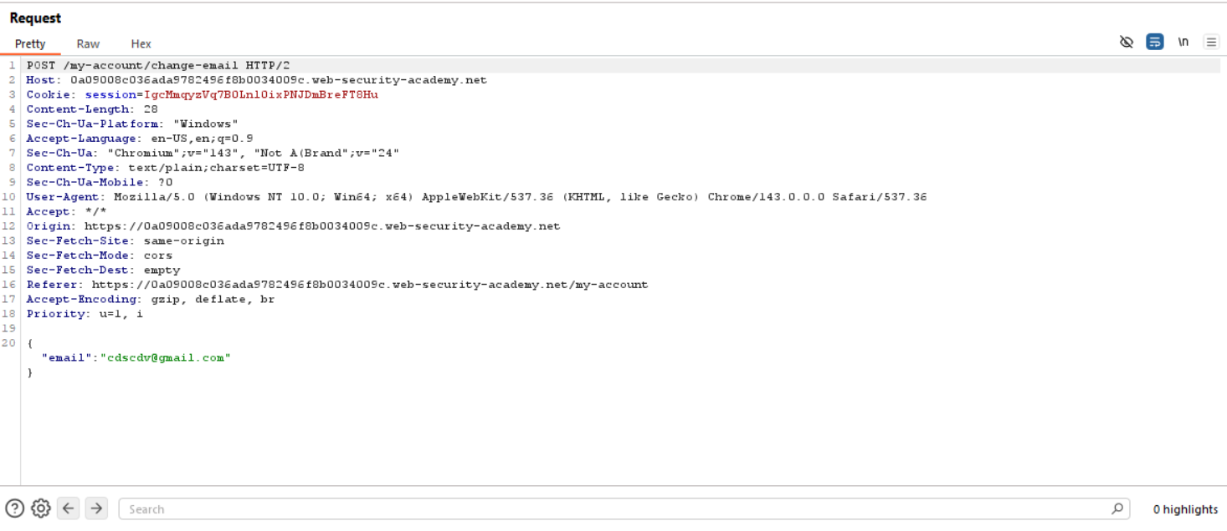

4️⃣ Identify Role ID in Response
- Observe the server response.
- Notice the JSON response includes a field similar to:
"roleid": 1
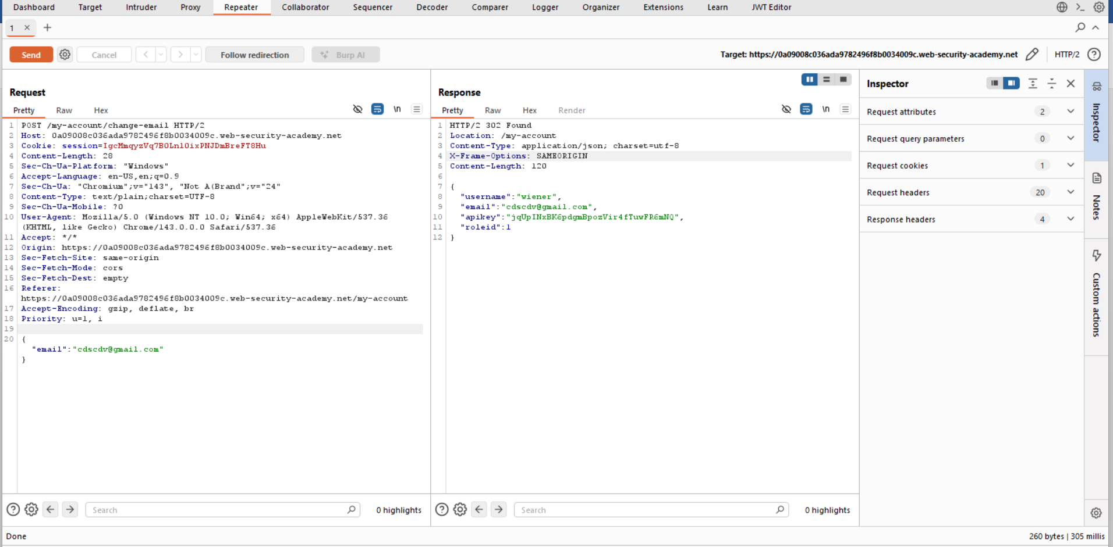

5️⃣ Modify roleid Parameter
- In Burp Repeater, modify the request body.
- Add or change the role ID to admin value:
"roleid": 2
- Send the modified request.
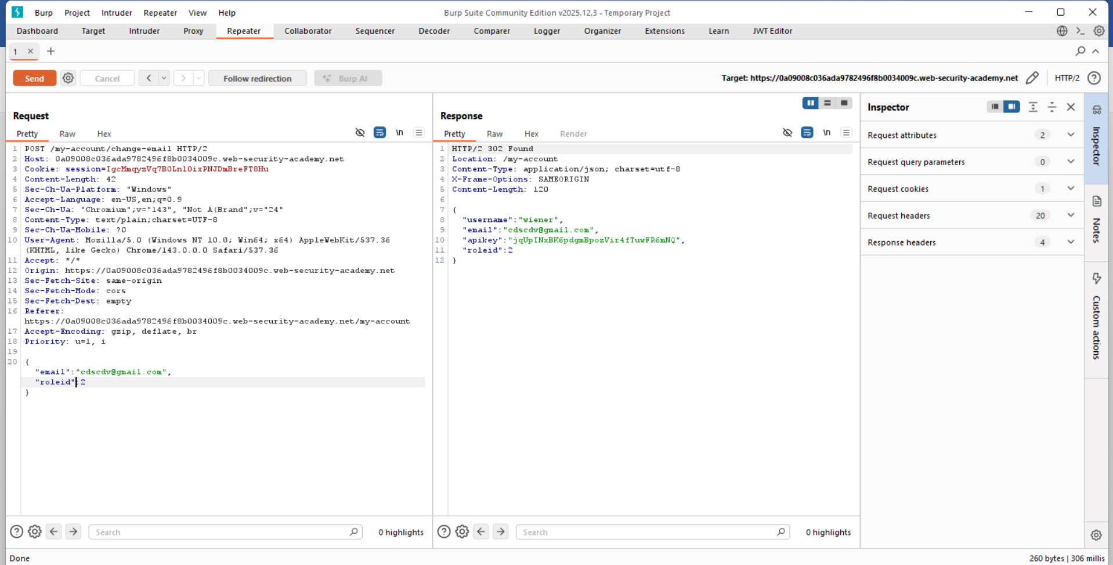

6️⃣ Verify Privilege Escalation
- Check the response again.
- Confirm that the role ID is now updated to 2.

7️⃣ Access Admin Panel
- Navigate to:
/admin
- You should now have admin access.

8️⃣ Delete User Carlos
- Locate user carlos in the admin panel.
- Delete the user to solve the lab.
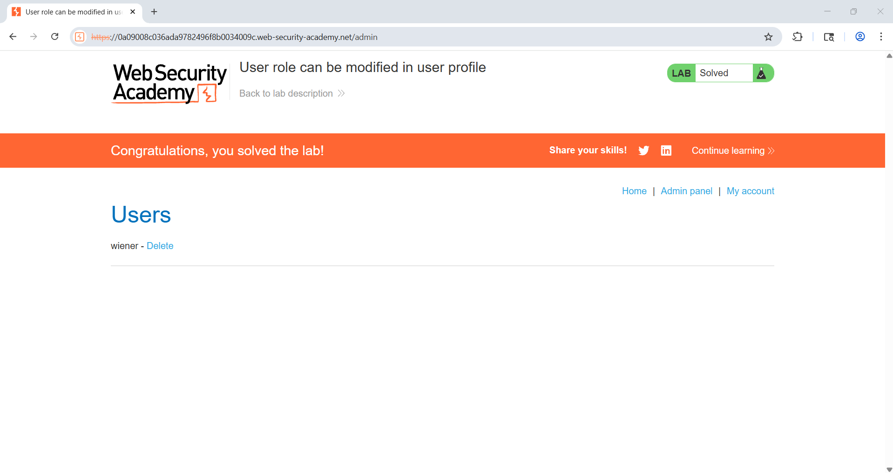

✅ Lab Status
✔ Lab Successfully Solved

🧯 Security Impact
- Unauthorized privilege escalation
- Full administrative access
- Account takeover and user deletion

🔒 Mitigation & Recommendations
- Never allow users to modify sensitive fields like roles client-side
- Enforce server-side authorization checks
- Use role-based access control (RBAC)
- Validate and whitelist allowed parameters

🧑‍💻 Author
- Chamika Jayasooriya
Field: Cybersecurity / Penetration Testing

